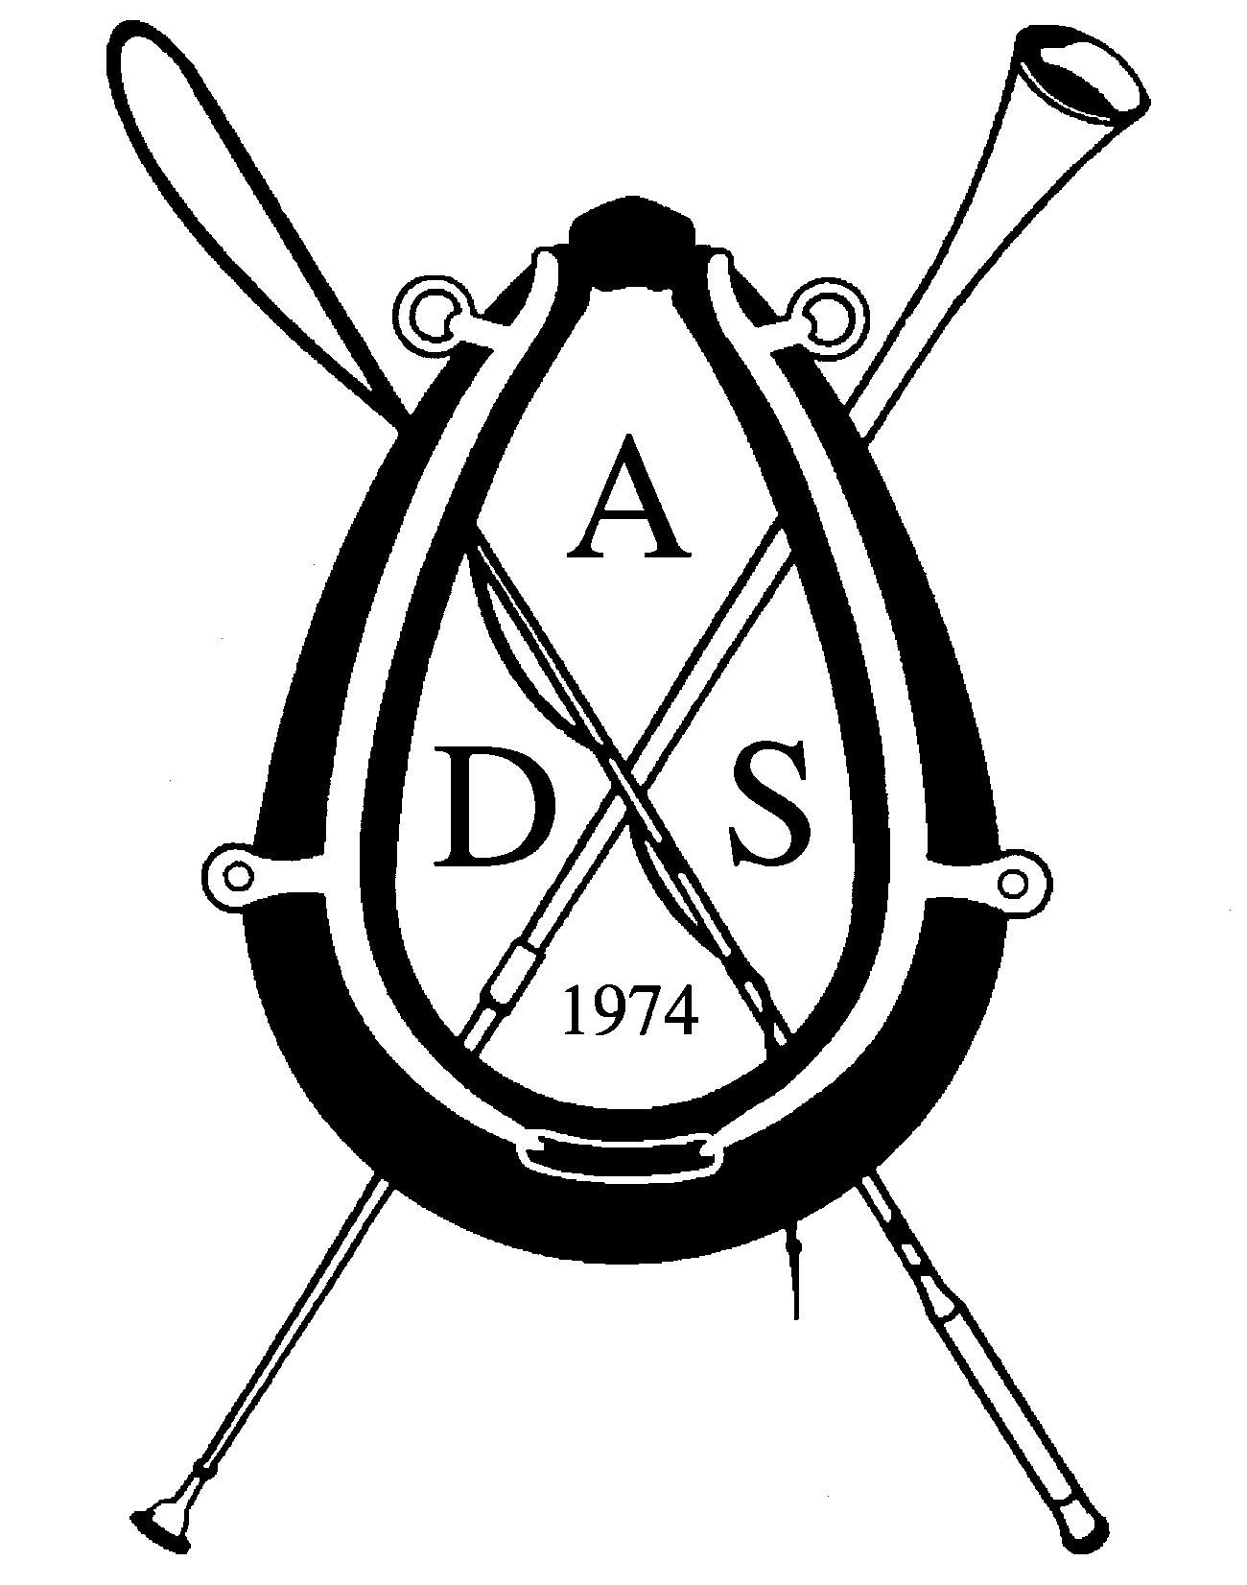
Combined Driving Competitions
Omnibus Information
For competitions Jan. 1-June 30, return by September 1
For competitions July 1- Dec 31, return by March 1

Please fill out the form below and e-mail it to: mailto:omnibus@americandrivingsociety.org as an attachment. In the subject line please put “Omnibus: Your Show Name”. Enter the required information into each of the gray boxes, they will expand to accommodate your text If you need further assistance contact us at 608-237-7382. Forms will not be accepted late or without payment.

Hickory Knoll CDE Training and Intermediate Levels
Fitchburg, Wisconsin
www.hickoryknoll.net
Competition Date July 20, 21 and 22, 2018 Rating: ADS
Entry Form: Use ADS combined driving form.
Entries Open: April 1, 2018 Entries Close: July 8, 2018
Method of Accepting Entries: Limited to seventy-five entries. Former competitors have reserved spots until June 1. New competitors accepted by date of postmark. Early entry recommended. A waiting list will be kept.
Special Qualifications: All competitors must be ADS members. Disabled drivers, youth and first time competitors are urged to enter. Disabled drivers should notify management if accommodations are required. Site is accessible.
Levels/Divisions: Training and Intermediate. Preliminary drivers must use the North American Championship Omnibus
Classes: VSE , Single Horse, Single Pony , Horse Pair/Tandem, Pony Pair/Tandem , Horse 4, Pony 4
Prize List? No
Organizer(s): The Hickory Knoll Fund, Inc. a 501 (c) 3
Secretary: John Freiburger, 5438 Highway M, Fitchburg, WI 53575 phone 608-835-7473, cell 608-212-0804,
email frei@chorus.net
Mail Entries to: Secretary Questions: frei@chorus.net
Officials
President of the Jury Boots Wright ; Ground Jury: Mary Ann Boyden and Lisa Singer
Technical Delegate: Erika Matulich Course Designer: John Freiburger Veterinarian: Irongate Equine Clinc;
Phone: 608-333-4070 EMT Service: Fitchburg Fire Rescue/ATV
Farrier: Achenbach Hoof Care (on call) 608- 212-8385 Scorer: Therese Aschkenase & Kia Block
Fees
Entry/Class Fees: $100.00; Post Entry Fees: $120; Entry Fee Refund Policy: If a wait listed competitor can take spot, less $25 office fee; Stall Fee: $125.00 for up to four nights; Stall Deposit: none; Stall Refund Policy: If a wait listed competitor can take stall, less $25 office fee; Other Fees: Golf Carts : are available for $160.00 RV fees are $25 per vehicle for the entire event. There will be an RV parking area.
Make Checks Payable to: Hickory Knoll Fund, Inc.
The Hickory Knoll Fund, Inc. is a 501c3 and sponsorships are very much appreciated and may be tax deductable. The entry and stall fees cover less than half the cost per competitor, thus your support is needed.

Tentative Schedule
Long distance guest barn open: Sunday July 16 to July 30 Stable Opens: Wednesday 4:00
Secretary’s Office Opens: Friday noon; Vet Check: no first inspection for Training and Intermediate; Course Walk and Briefings: Friday 4:30; Safety check Saturday 8:00 Dressage: Friday 8:15; Marathon: Saturday 8:15 Cones: Sunday8:30 ; Social Events: Friday Dinner Social 5:30, Sunday Awards Party 4:00 A Saturday dinner may also be offered.
Dressage
Test(s): Training (all): Test 4 POM, Intermediate (all) Test 7 POM
Ring/Warm-up area Footing: Training and VSE 80 meter: lime fines arena. Intermediate 80 and 100 meter grass arena : as per tests. Warm up: 80 m on grass

Marathon
Terrain: Section A: 1 k asphalt, then grass trails and farm roads, gentle rises, one area of Intermediate trail is stony, VSE Section A 2K asphalt
Walk Section : smooth asphalt, slight downgrade for part, No walk for VSE
Section B: grass trails and lanes, VSE 5 obstacles, Training and Preliminary 5 obstacles, Intermediate 6 obstacles
Note: Dry routes will be provided for Training in the water obstacle.
Cones
Ring/Warm-up area Footing: Grass / Grass
Level: Training: Clearance: track plus 35cm
Level: Intermediate: Clearance: track plus 25cm

Other Information
Veterinary/Health Requirements: Negative Coggins within 1 year of show date , flu/rhino vaccination within six months of show date.
Stabling Information: Temporary stalls located in tents, all competitors must take stalls unless given permission to show from trailer in advance. VSEs and small ponies may share a stall.
Grooms may navigate for two competitors in different divisions if the schedule allows.
Misc. Show info: Friday and Sunday parties for whips and grooms are free. Dogs must be leashed at all times.
Awards Offered: Ribbons 1 to 6, Divisional Championships, Best Conditioned, Best Dressage, The Max Award
Food Available on the Grounds: Yes
Accommodations: Room block is reserved at $89.00 per night at the Wyndham, Garden Hotel in Fitchburg
https://www.wyndhamhotels.com/wyndham-garden/fitchburg-wisconsin/wyndham-garden-fitchburg-madison

Early Arrival: available by contacting Secretary for arrangements. Stalls or paddocks will be available for long distance arrivals earlier in the week as necessary.
Camping Available: Yes, on grounds, limited hook-up, reservations are required; email frei@chorus.net
Directions: From Illinois: Take I-90 north to first Madison exit. Go west on Hwy. 12/18 to Hwy. US 14 east (actually goes south), go 6 miles to Oregon exit. Stay on exit ramp until you can turn right (west) on Hwy. M. Go 2 miles to Hickory Knoll Farm. From Minneapolis: Take I-90 south to exit Hwy. 12/18 west, which is well marked. Go west on 12/18 to Hwy. US 14 east (actually going south) go 6 miles to Oregon exit. Stay on the exit ramp until you turn right (west) on Hwy. M. Go 2 miles to Hickory Knoll Farm. From Eastern Wisconsin: Take US 151 or I-94 to I-90 south then follow directions above. From Iowa: Take US 151 to Verona. Exit at Hwy. PB, take PB right one block, then left (east) on M. Go 5 miles to stop sign. Continue straight 1/2 mile after stop sign to Farm.

Hickory Knoll Fund Inc. is a charitable foundation making grants in natural resource and equine education with a focus on access for the disabled. Event profits, if any, remain with the foundation. To help sponsor the event or the foundation, please email the secretary.

*By completing this application, the Organizer(s) agree to conduct this competition in accordance with the rules, regulations and directives of the American Driving Society.

** I have sent this application to our TD for review and Input prior to sending it to the ADS.

Name of Organizer John S Freiburger

