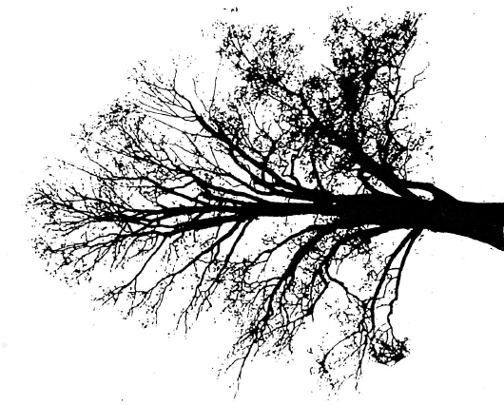

**The Hickory Knoll Fund, Inc.**

5438 Highway M, Fitchburg WI 53575 frei@chorus.net

**The American Driving Society North American**

**Preliminary Championship**

**January 19, 2018**

Hickory Knoll wishes to announce that our Fitchburg facilities, composed of Hickory Knoll, Frostwood, and McGibbon farms will host the 2018 ADS North American Preliminary Championship.

The event will be held Friday, Saturday, and Sunday July 20, 21, and 22. Entries open April 1 and are limited to a total of 75 competitors in all divisions. We will offer Training and Intermediate levels as well as the Preliminary Championship. We will not offer a non-championship Preliminary level.

First inspection for championship horses will take place at 4:00 Thursday the 19th and a Section 1 review and drivers’ meeting will take place on Friday at 4:30.

Over 100 stalls will be made available for competitors, and carriage storage will be available under the stabling tent. Facilities are available for competitors who wish to arrive prior to the official opening of the stable on Wednesday afternoon by making a request for stalls in our permanent guest barn.

An RV parking area will be provided; a $25 fee covers the entire weekend.

Iowa Valley Carriage Supply and Midwest Custom Carriages have confirmed they will be on site and we expect other vendors as well. Food will be available on the grounds. Midwest Custom Carriages will provide morning coffee at their tent.

A block of 75 rooms has been reserved at the Fitchburg Wyndham Garden Hotel, 5.7 miles from Hickory Knoll Farms, and in walking distance to brewery, restaurants and cafes. Details:

* Special Rate $89/night beginning July 16 through the next Monday
* Check-In: 3:00pm, Check-Out: 11:00am. Guests making individual reservations must identify themselves as part of the group in order to take advantage of the special group rate. Rates do not include tax.
* Room rate includes in-room kitchens, complimentary high-speed wireless internet, free local phone calls, pool and whirlpool, and fitness center. Each guest will get 50% off an entrée at the Wyndham Garden breakfast café for breakfast and can receive $5 off with room key for the on-site restaurant Tuscany Grill.
* Fitchburg Visitor Experience Package
* Contact: Wyndham Garden Suites, 2969 Caddis Bend, Fitchburg, WI 53711   
  Phone: (608) 274-7200, Email: <Dos@HatcheryHillHotels.com>

The Hickory Knoll Fund Inc. (I.D number 30-019000) is a 501(c)3 public charity and donations are deductible.